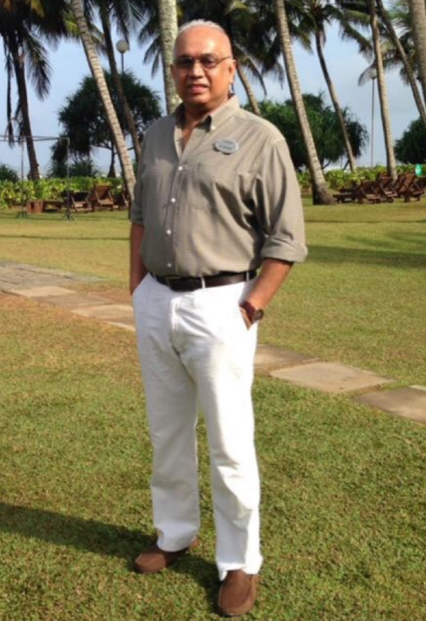
Mr. Roshan Fernando
General Manager at The Golden Crown Hotel
Sri Lanka

Mr. Roshan Obtained the management diploma from Ceylon Hotel School & School of Tourism in hotel and catering operations with specialization in Food and Beverage operations – Final – 1981- in Sri Lanka.
He is currently working as the General Manager of The Golden Crown Hotel Kandy. He has 25 years’ experience as General Manager in five star Resorts, Boutique Hotels & City Hotels. He successfully completed two year contract with Hotel Tugu Lombok / Bali, Indonesia. He Completed 18 Months contract with Sun Spa Resort & Villas (a five star 325 roomed hotel) in Vietnam as Deputy Director General/ General Manager.
He also worked at Amara Sanctuary Resort Sentosa, Singapore, A 5 star luxury Boutique hotel- in Singapore as the General Manager. He have worked at Amara Saigon in Vietnam 285 rooms (now known as Ramana Saigon) as the General Manager.
Mr. Roshan have been a Director Operations in charge of 9 hotels (Inclusive of 3 five star hotels and 3 four star hotels in Sri Lanka) - Annual Turnover of US$ 30 Million. He have pre-opening experience of two five star hotel namely and 300 roomed Taj Palace Hotel in New Delhi India in 1981 and 350 roomed Taj Samudra Hotel in Colombo. He has specialized in the food & Beverage operations in the Sri Lanka Hotel School.
Mr. Roshan also conducted training in F&B & in Housekeeping areas in Taj Hotels (India & Sri Lanka) and been a visiting lecturer at the Ceylon Hotel School and School of Tourism in Sri Lanka for 5 years. A Guest lecturer at the Temasek Polytechnic & the Tourism Academy in Singapore. He was involved in setting of the hotel services, standards operational procedures and training for new recruits. He trained 150 new associates in New Delhi India for Taj palace hotel & 200 new associates for Taj Samudra hotel, Sri Lanka.

